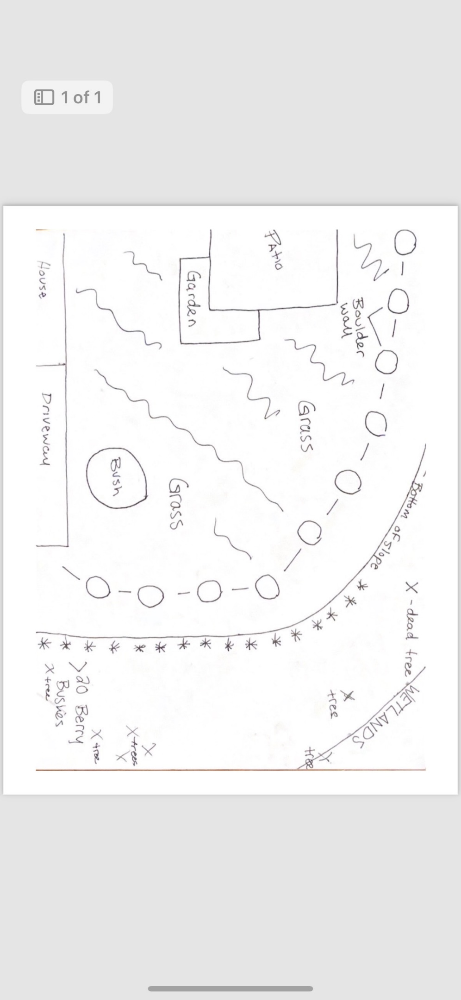

Submitted by John McGeoghan Sept 10, 2024 at 7:06 pm

